**Cost centres**

1022 – Building Construction and paving

1023 – General Construction and Infrastructure

1024 – Forestry

1025 – Mining

Go to the Equipment and check the product Group. That may give you an idea if not.

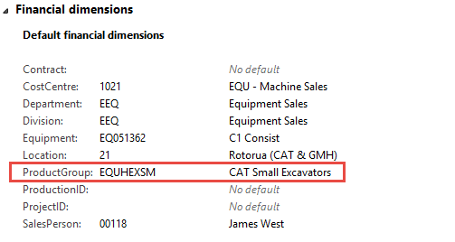

On the Equipment you will find the item Number

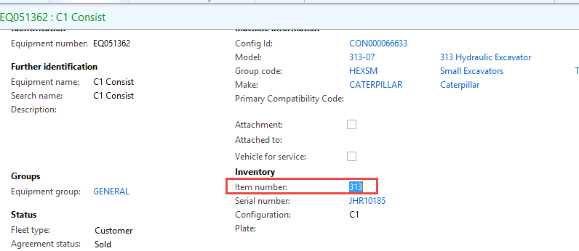

It tells you that it should be 1023 – so you go to the Equipment and change the cost centre in the FD Tab from1021 to 1023

